Marie Battle

Joshua Hamm

Erik Hernandez

Kody Pope

8-30-24

Assignment 5.1

Moffat Bay: Database Dev Assignment:

For this module's assignment, you will be building the Database for the Moffat Bay project.

1. Screenshots:
   1. Lodge Table:
      1. 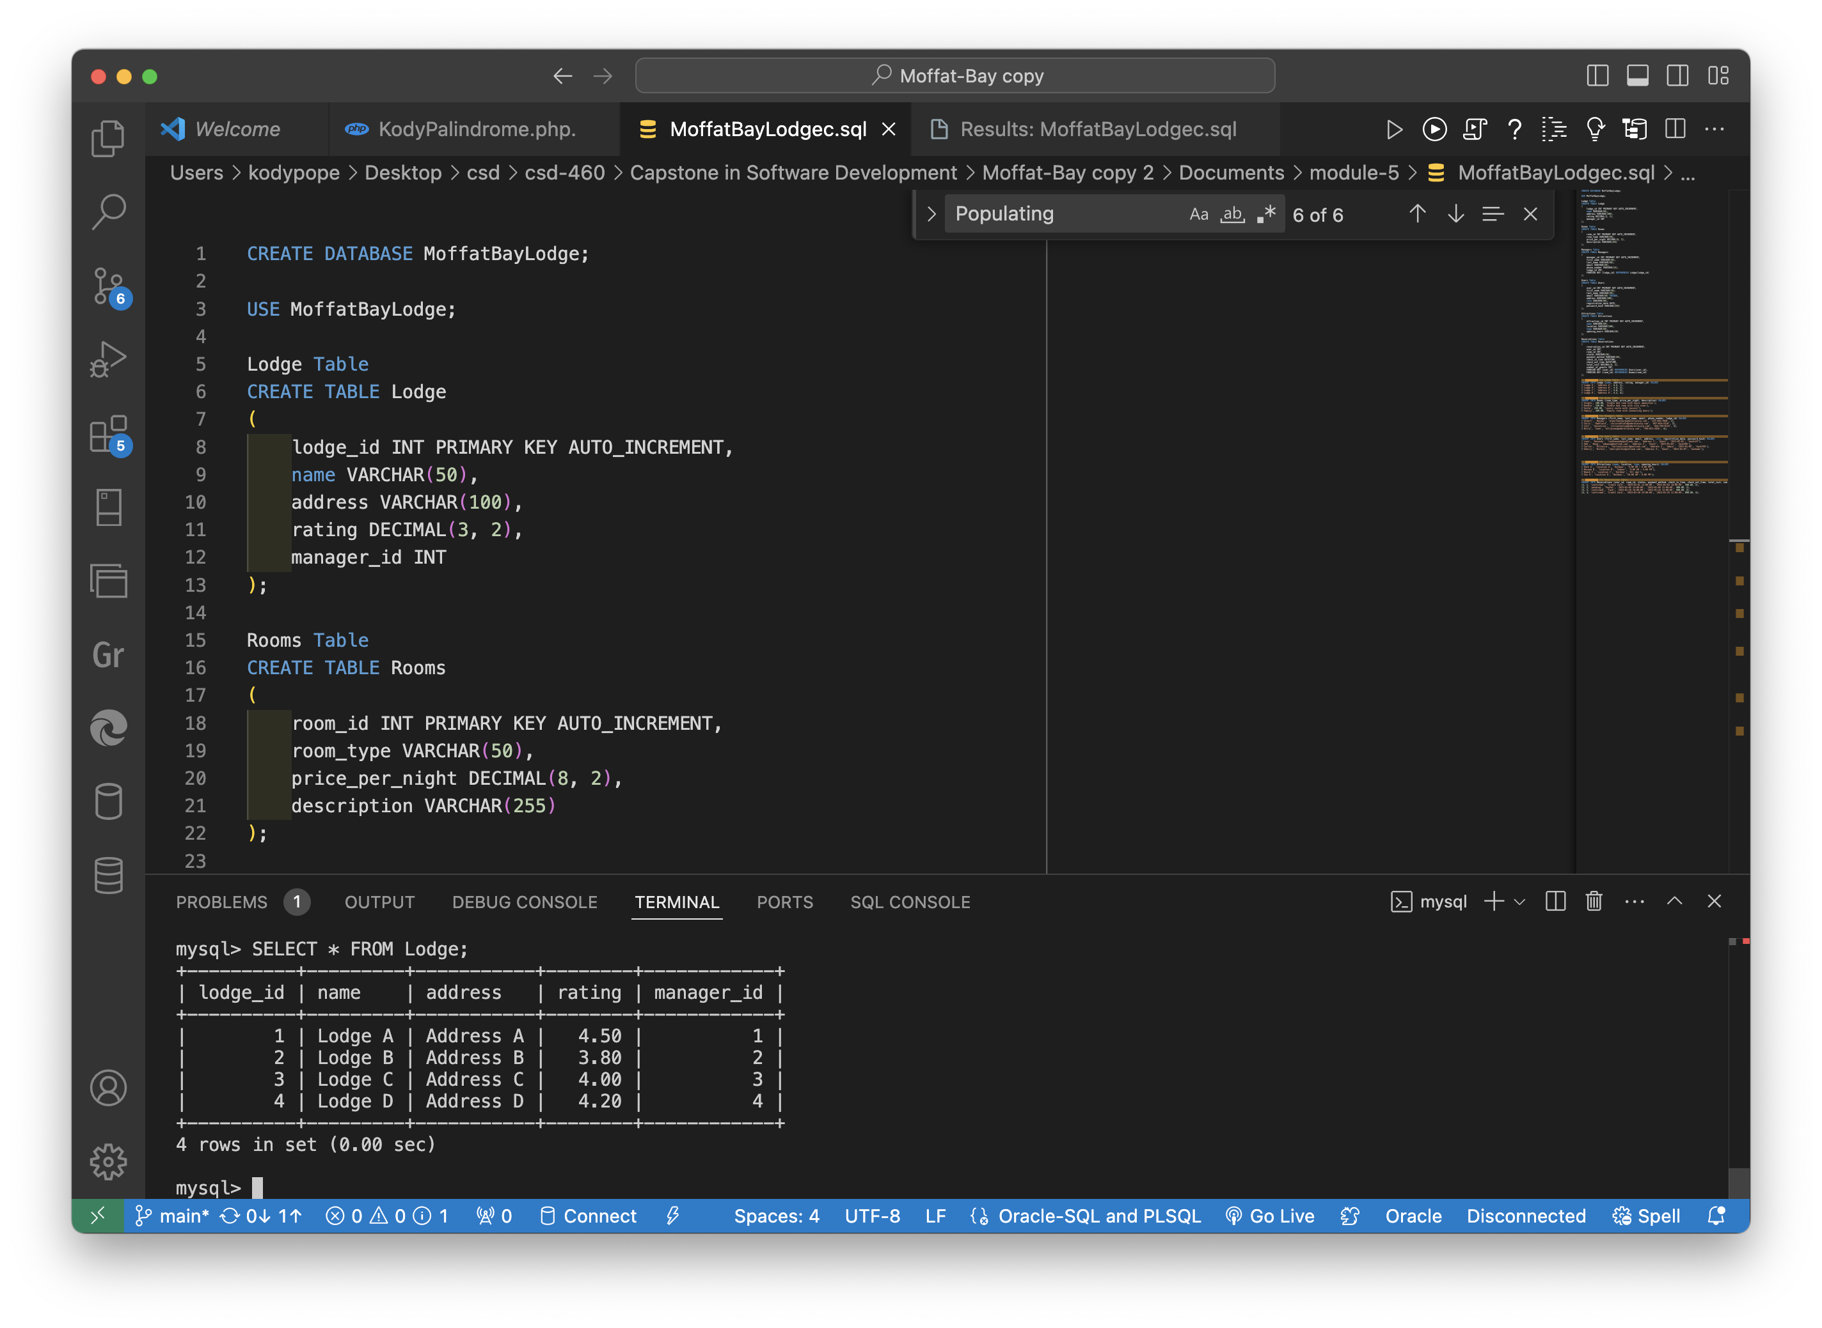
   2. Rooms Table:
      1. 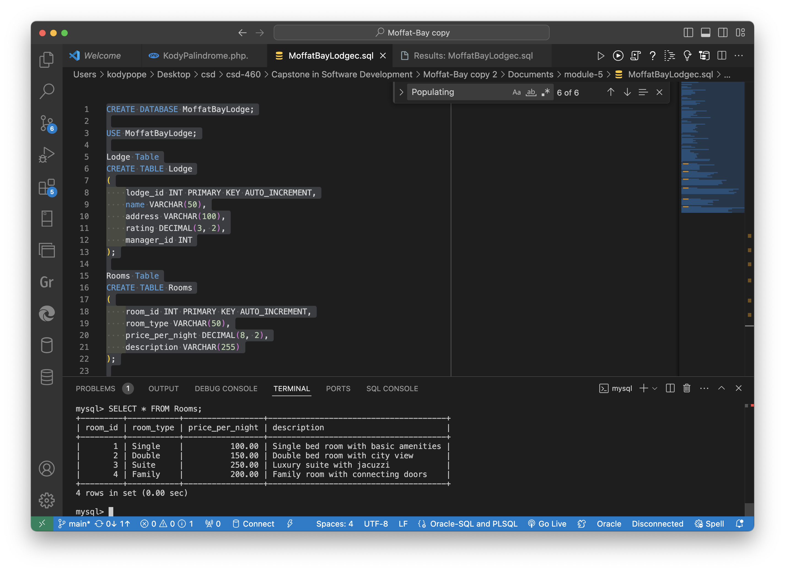
   3. Managers Table:
      1. 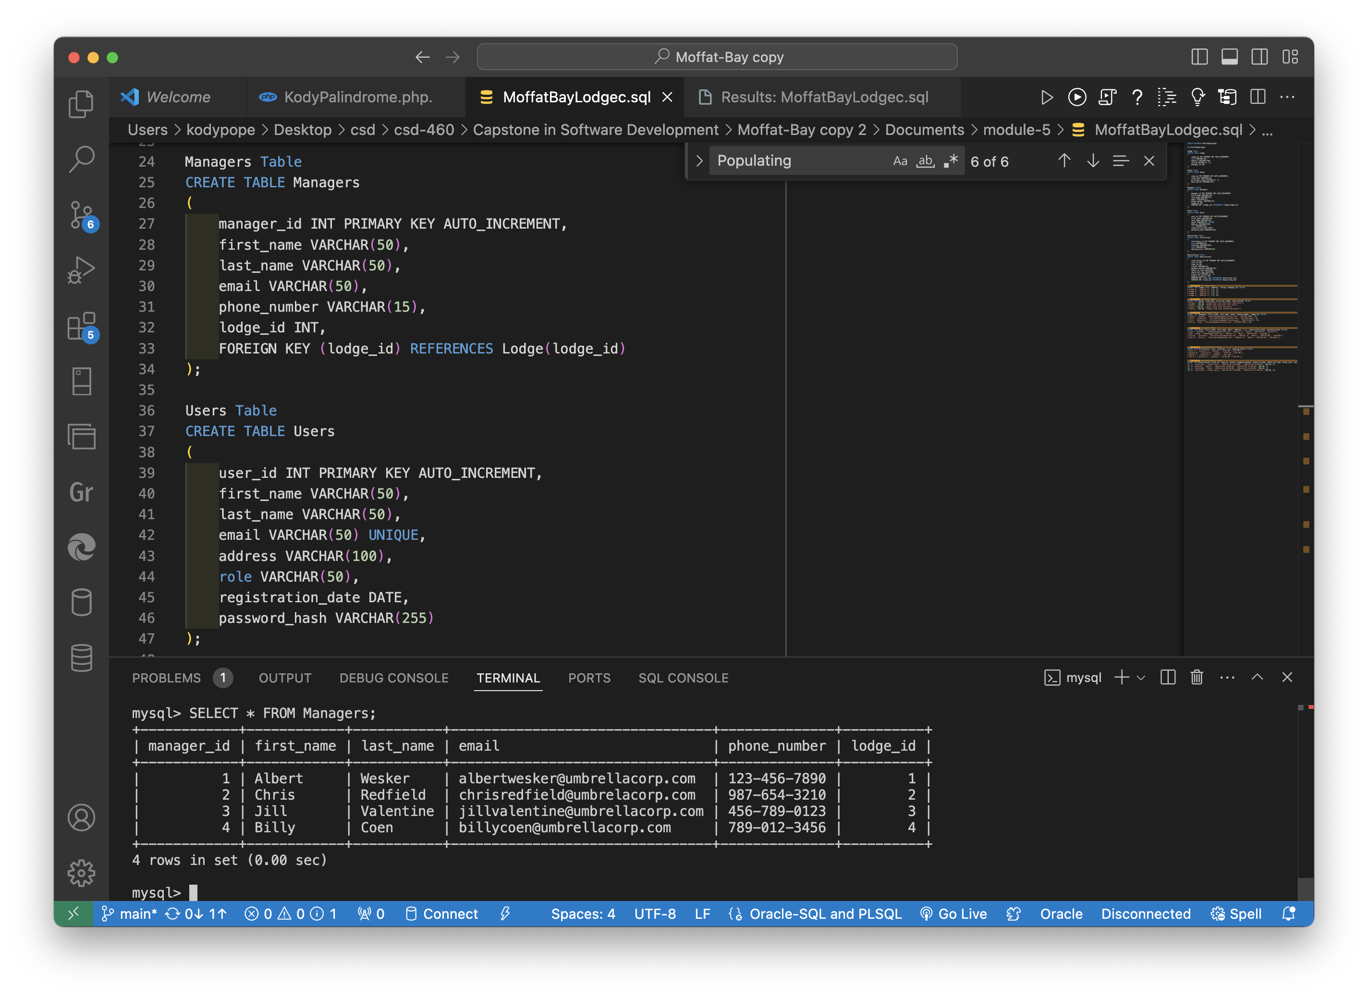
   4. Users Table:
      1. 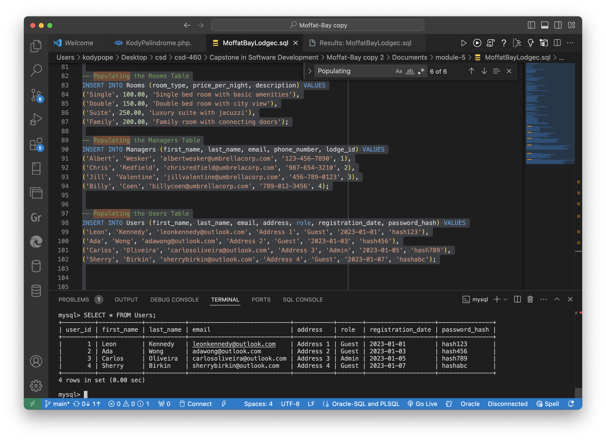
   5. Attractions Table:
      1. 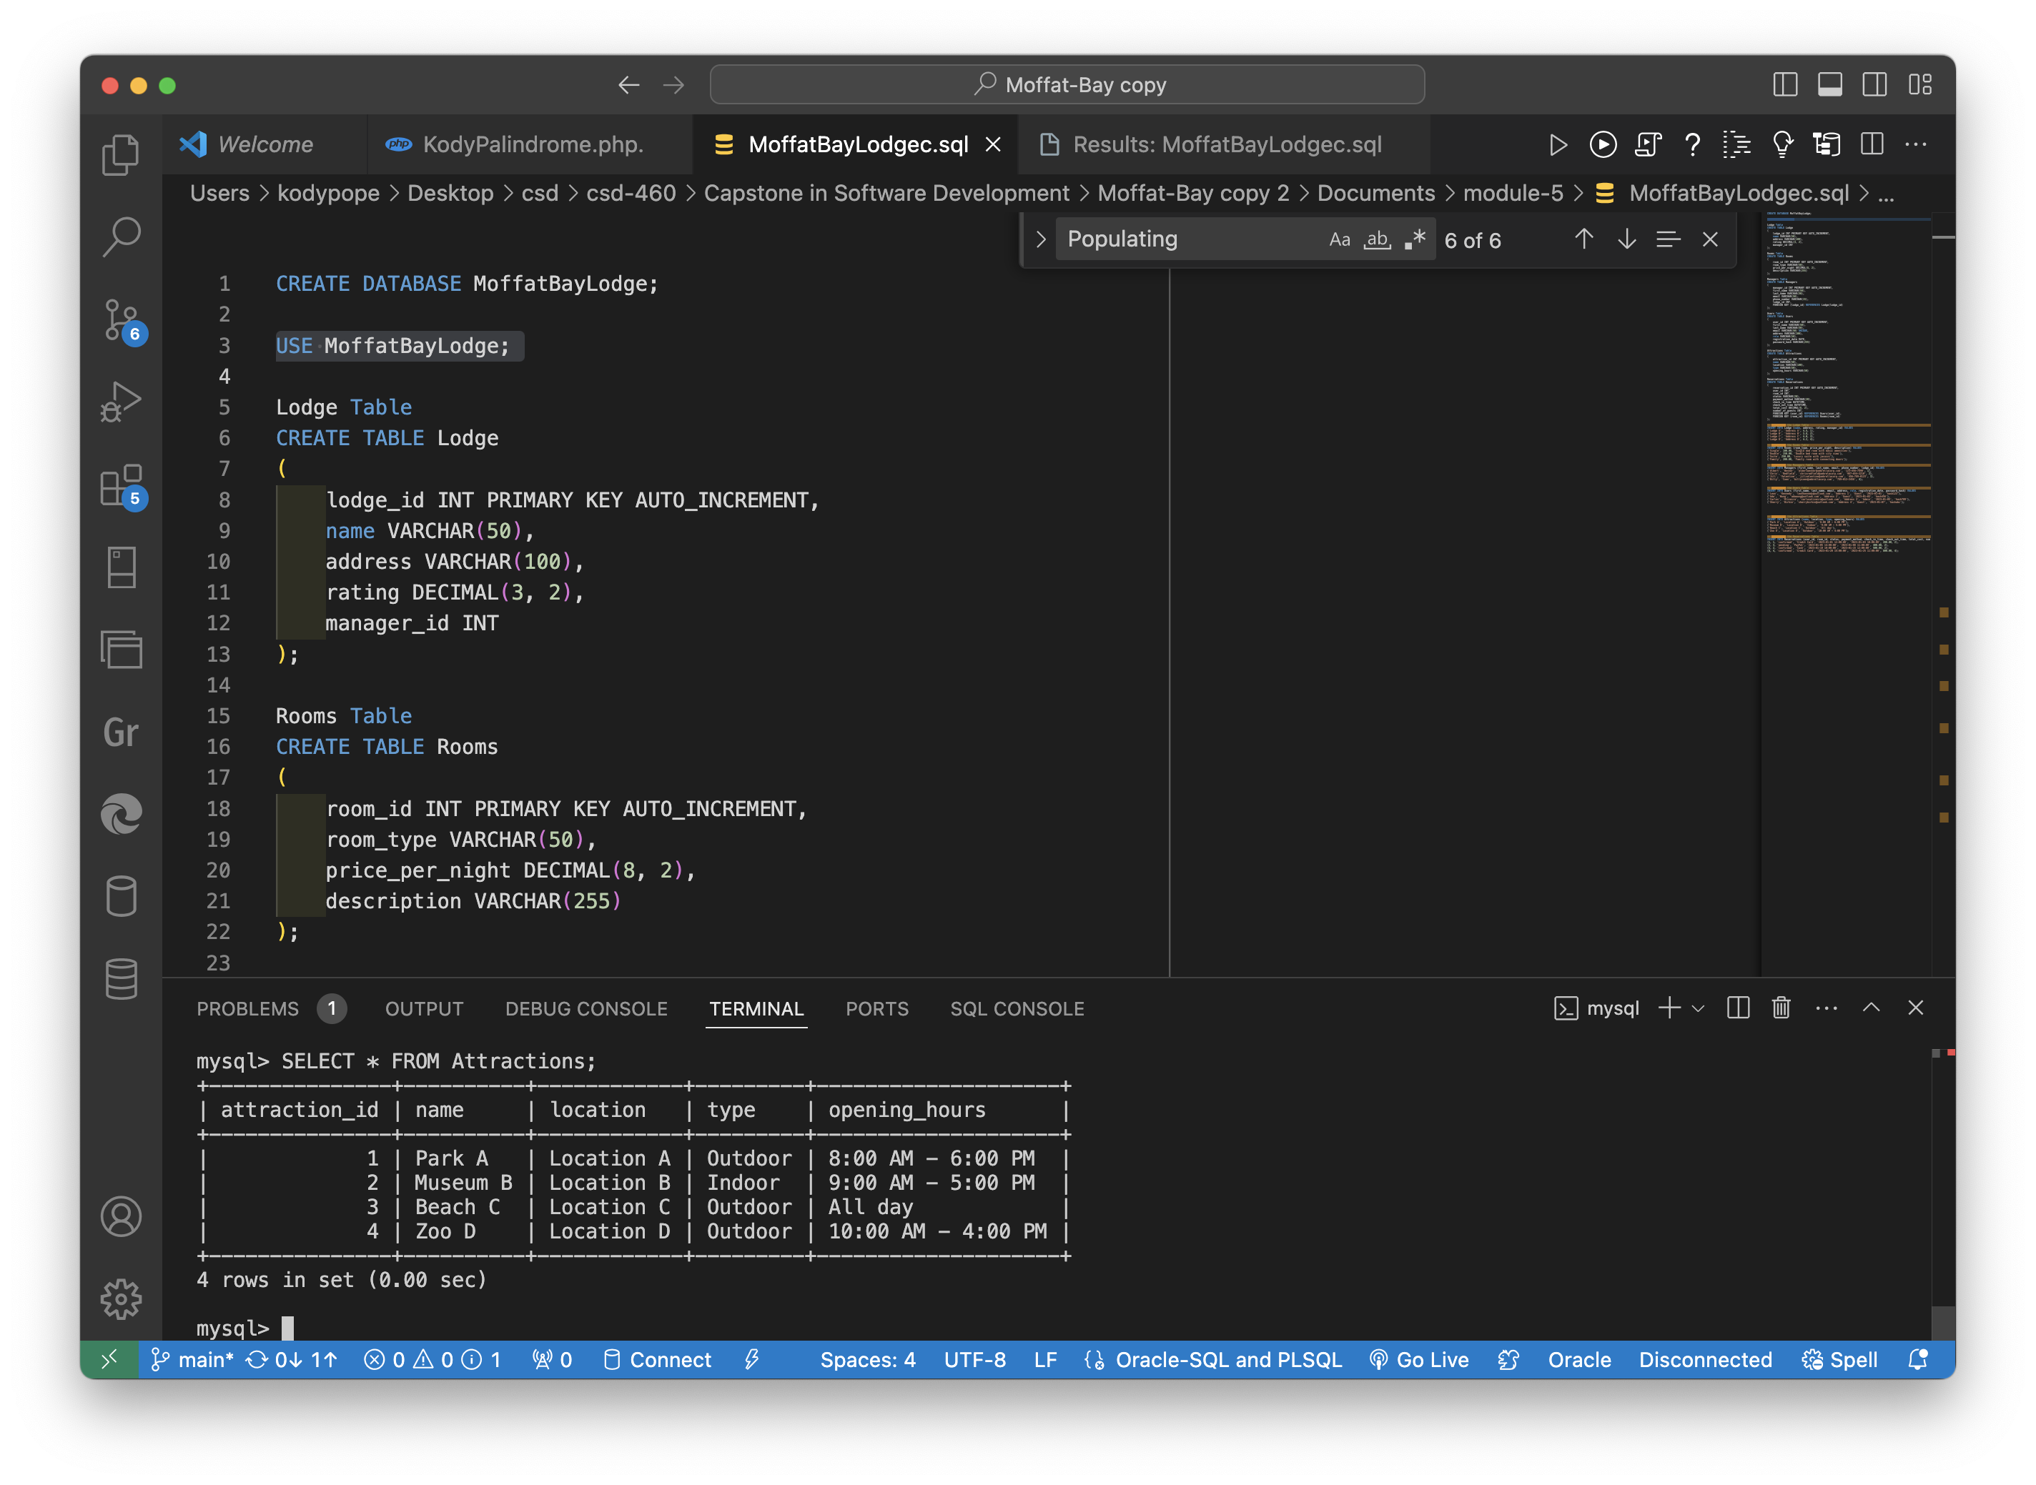
   6. Reservations Table:
      1. 